Report On

**The Impact of ICT in Preserving and Promoting Indigenous Cultures and Languages**

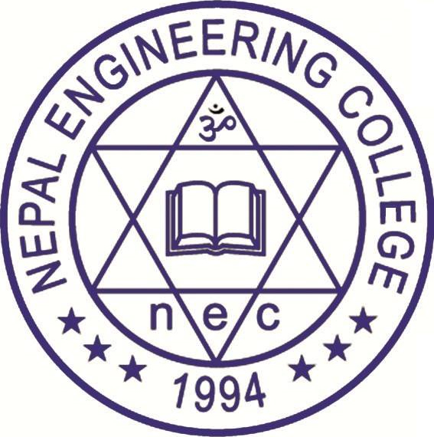

Submitted To

**Department of Computer Science and Engineering**

**Nepal Engineering College**

In partial fulfillment of the requirements

Requirements for the Degree of **B.E. in Computer Science**

Submitted By:

**Aakriti Ghimire (022-301)**

**Ashreeya Khadka (022-313)**

**Ayush Dev (022-314)**

**Chand Thakur (022-317)**

**Date:** 2024-07-30

# ACKNOWLEDGEMENT

We would like to extend our deepest gratitude to the Department of Computer Science and Engineering at Nepal Engineering College for their invaluable support and guidance throughout the course of this project. Their expertise and resources have been instrumental in the successful completion of this work.

I am particularly grateful to Professor Krishna Bikram Shah for his unwavering support, insightful guidance, and encouragement. His profound knowledge and commitment to excellence have been a source of inspiration and motivation. The constructive feedback and suggestions provided were pivotal in refining and enhancing the quality of this project.

I also wish to thank all the faculty members and staff of the Department of Computer Science and Engineering for their assistance and cooperation. The collaborative environment and access to the necessary facilities and tools provided a conducive atmosphere for research and development.

Finally, I would like to express my appreciation to my peers and colleagues for their constant support and shared enthusiasm. Their camaraderie and teamwork have been crucial in overcoming challenges and achieving our goals.

Thank you all for your contributions and support.

# ABSTRACT

This study is exploratory research into the preservation of indigenous languages and cultures through information technology. ICT provides invaluable knowledge and aid in preserving and promoting indigenous cultures and languages. In the context of Nepal, youths are highly influenced by Western culture, which is leading to the erosion of Nepali culture. Hence, ICT could play a crucial role in preserving Nepali cultures. Due to advances in technology, the world has become a smaller place, and as a result, people have been more exposed to Western culture compared to previous generations. For a harmonious multiethnic society, linguistic and cultural diversities require respect and recognition. Moreover, cultures can be preserved through the use of technology such as digital archiving, internet archives, and virtual reality. Historical locations and events can be recreated in virtual and augmented reality. Social media platforms also encourage cultural sharing, which leads to the preservation of endangered cultures and languages. With the rise of various technologies, people from different cultures can now easily communicate and share their knowledge, experiences, beliefs, and traditions with each other. By bridging the gap between technology and tradition, this research aims to safeguard indigenous cultures and languages in Nepal and beyond.

[**Keywords**: Information and Communication Technology (ICT), Indigenous Cultures, Globalization, Technological Advancements]

# Table of Contents

ACKNOWLEDGEMENT i

ABSTRACT ii

Table of Contents iii

List of Figures v

List of Tables vi

Introduction 1

Overview of the project. 1

Information and Communication Technology 2

Motivation for Research Work 3

Research Aim and Scope 4

Aims 4

Objectives 4

Significance of Research 4

Scope of Research 5

LITERATURE REVIEW 7

1. Understanding Indigenous Cultures and Languages in Nepal 7

Exploring the resilience and wisdom embedded within indigenous cultures 7

2. From Pixels to Traditions: Nepal's Cultural Renaissance in The Digital Age 9

Cultural Fusion in Virtual Realms: Gaming as A Catalyst for Global Understanding 9

3. Social Media Synergy: Nurturing Cultural Heritage Through Social Media Networks 10

4. Nepal's Cinematic Odyssey: From Kathmandu's Ancient Alleys to Cannes' Glittering Red Carpet 10

SWOT Analysis for ICT in Preserving and Promoting Indigenous Cultures and Languages in Nepal 12

Threats and Limitations 12

Weakness and Problems 13

Solutions and Opportunities 13

METHODOLOGY 14

**Research Design** 14

**Participants** 14

**Data Collection Methods** 15

15

**Data Analysis Techniques** 20

**Ethical Considerations** 20

DATA ANALYSIS AND FINDINGS 21

DISCUSSION 22

CONTRIBUTIONS AND FUTURE WORKS 23

Budget Details 24

List of Experts 26

Project Phases 26

Project Schedule 27

Work Scheduling and Planning 29

REFERENCES 1

# List of Figures

Figure 1: Impact on Indigenous Cultures and Languages 1

Figure 2: Information and Communication Technology (ICT) 2

Figure 3: Indigenous Groups in Nepal 5

Figure 4: Nepal’s Ethnic Groups Diversity 7

Figure 5: Fusion of indigenous cultures within a vibrant, futuristic gaming environment, emphasizing global understanding and cultural preservation through technology 8

Figure 6: Vibrant use of social media to nurture and promote the cultural heritage of Nepal 10

# List of Tables

Table 1: Budget Details 15

Table 2: Project Schedule 16

Table 3: Work Scheduling and Plan 17

# Introduction

## Overview of the project.

The rapid advancement of Information and Communication Technologies (ICT) has transformed various sectors globally, including education, healthcare, and commerce. One critical and often overlooked area where ICT can make a significant impact is the preservation and promotion of indigenous cultures and languages. Indigenous cultures are rich in history, traditions, and languages, many of which are at risk of being lost due to globalization, modernization, and the decline in the number of native speakers. ICT provides innovative tools and platforms that can help document, preserve, and revitalize these invaluable cultural assets.

Indigenous cultures and languages face numerous challenges in the contemporary world. Globalization has led to the dominance of major languages like English, Spanish, and Mandarin, often at the expense of minority and indigenous languages. Many indigenous communities are experiencing a decline in the number of fluent speakers, particularly among the younger generations, leading to an erosion of cultural identity and heritage. According to UNESCO, nearly 40% of the approximately 6,700 languages spoken worldwide are at risk of disappearing. In this context, ICT can play a pivotal role by providing accessible, scalable, and effective means for documenting and revitalizing endangered languages and promoting cultural heritage.

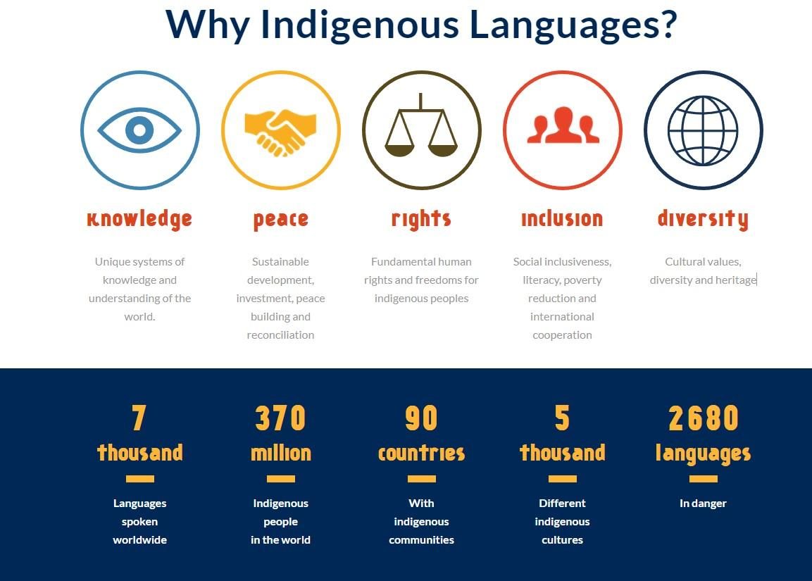Several initiatives have already demonstrated the potential of ICT in this realm. Digital archives, mobile applications, social media, and online learning platforms are being utilized to record oral traditions, teach languages, and share cultural practices. These technologies not only help preserve existing knowledge but also engage younger generations, thereby fostering a renewed interest and pride in their cultural heritage.

*Figure 1: Impact on Indigenous Cultures and Languages*

**(Source: https://en.iyil2019.org/)**

## Information and Communication Technology

Information and Communication Technology (ICT) refers to a broad range of technological tools and resources used to communicate, create, disseminate, store, and manage information. ICT includes both hardware and software solutions, and it encompasses various technologies used for information processing and communication.

In the context of this research, ICT encompasses a wide range of technologies and tools that can be used to preserve and promote indigenous cultures and languages, including:

* **Digital Archiving Tools:** Software and platforms for creating and maintaining digital records of cultural and linguistic materials.
* **E-Learning Platforms:** Online educational tools and applications that facilitate language learning and cultural education.
* **Social media:** Platforms that allow for the sharing and promotion of cultural content.
* Virtual and Augmented Reality: Technologies that can recreate historical locations and cultural experiences in immersive ways.
* **Mobile Applications:** Apps designed for language revitalization, cultural documentation, and community engagement.
* **Internet and Telecommunications Infrastructure:** The necessary backbone to support all these digital tools and ensure accessibility to indigenous communities.

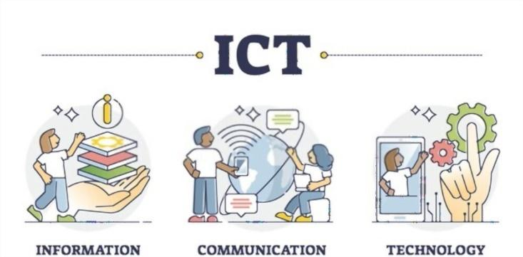

*Figure 2: Information and Communication Technology (ICT)*

## Motivation for Research Work

The motivation for this project is underscored by the urgent need to address the cultural and linguistic erosion faced by indigenous communities. The preservation and promotion of indigenous cultures and languages are not merely about maintaining diversity; they are crucial for the survival of unique worldviews, traditional knowledge, and sustainable practices that have been honed over centuries.

This project is timely due to several factors:

**Technological Accessibility:** The increasing penetration of the internet and mobile technology, even in remote areas, provides an unprecedented opportunity to reach and empower indigenous communities.

**Global Awareness:** There is growing global awareness and recognition of the importance of cultural diversity, as reflected in international frameworks such as the United Nations Declaration on the Rights of Indigenous Peoples (UNDRIP) and the International Decade of Indigenous Languages (2022-2032).

**Innovative Solutions:** The continuous evolution of ICT offers innovative solutions that were not previously available, making it possible to create interactive, engaging, and user-friendly platforms tailored to the needs of indigenous communities.

In conclusion, leveraging ICT for the preservation and promotion of indigenous cultures and languages is not only feasible but also imperative. By harnessing the power of modern technology, we can help ensure that these rich cultural heritages are not lost to future generations but are instead celebrated and integrated into the global cultural mosaic.

## Research Aim and Scope

### Aims

1. **To Develop and Implement Digital Strategies for Online Heritage Promotion:** Create and apply digital strategies to effectively promote cultural heritage online.
2. **To Identify and Evaluate ICT-Based Measures for Cultural Heritage Preservation:** Determine and assess ICT-based methods that support the preservation of cultural heritage.
3. **To Facilitate Broad Community Engagement and Participation through ICT Platforms:** Encourage widespread community involvement and participation using ICT platforms.
4. **To Design and Create Interactive Content and Gamification Strategies for ICT Promotion:** Develop and implement engaging content and gamification strategies to enhance ICT-based cultural promotion.

### Objectives

1. **To Examine How ICT Promotes and Preserves Diverse Cultures Globally:** Investigate the ways in which ICT contributes to the promotion and preservation of various cultures worldwide.
2. **To Explore ICT Potential in Order to Identify Various Challenges and Opportunities:** Analyze the potential of ICT to uncover different challenges and opportunities in cultural preservation.
3. **To Document and Analyze Specific Case Studies Where ICT Has Been Effectively Used to Preserve Cultural Heritage:** Record and evaluate particular instances where ICT has been successfully utilized for cultural heritage preservation.

## Significance of Research

* **Cultural Preservation:** ICT helps document and archive endangered cultures and languages.
* **Language Revitalization:** Digital tools support learning and revitalizing endangered languages.
* **Educational Opportunities:** ICT provides educational resources in indigenous languages, enhancing learning and cultural pride.
* **Access to Information:** It gives indigenous communities access to valuable information and resources.
* **Community Empowerment:** ICT empowers communities to advocate for their rights and participate in global conversations.
* **Economic Development:** ICT enables new economic opportunities, such as e-commerce and cultural tourism.
* **Research and Collaboration:** It facilitates research and collaboration to develop effective preservation strategies.
* **Visibility and Representation:** ICT increases the visibility of indigenous cultures, promoting positive representation and appreciation.

## Scope of Research

* **Documentation and Archiving:** Providing guidelines for using digital tools to document and store indigenous languages and cultural practices.
* **Language Revitalization:** Developing guidelines for apps and online resources to teach and promote endangered languages.
* **Educational Integration:** Providing guidelines for digital curricula and resources to incorporate indigenous knowledge into education.
* **Community Engagement and Empowerment:** Enabling communities to share their stories and advocate for their rights using ICT.
* **Economic Opportunities:** Exploring guidelines for e-commerce and digital entrepreneurship to promote cultural tourism and sell indigenous products.
* **Health and Social Services:** Improving access to health information and services in indigenous languages via ICT.
* **Policy and Governance:** Analyzing and developing policies to support ICT initiatives for cultural preservation.
* **Technological Innovations:** Investigating new technologies like AI and VR for cultural preservation.
* Barriers and Challenges: Identifying and addressing obstacles to ICT adoption in indigenous communities.
* **Case Studies and Best Practices:** Studying successful ICT projects and compiling best practices for cultural preservation.

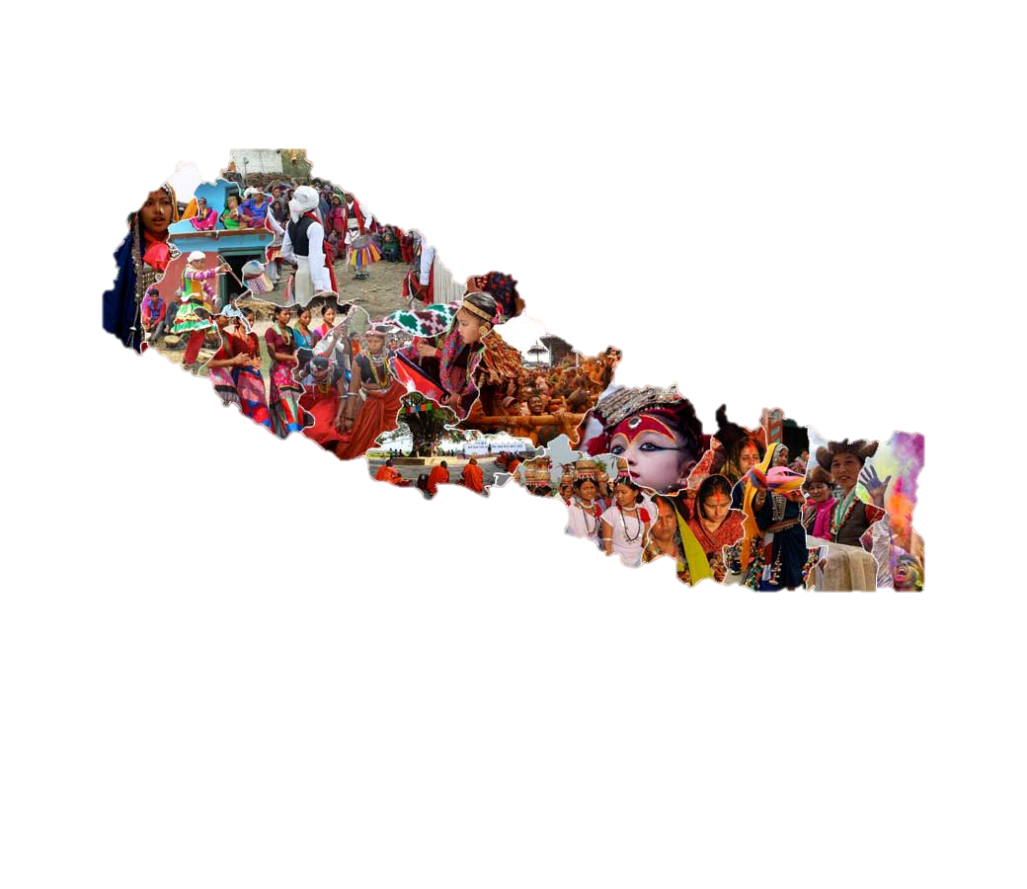

*Figure 3: Indigenous Groups in Nepal*

**(Source: Vianet Communications)**

# LITERATURE REVIEW

In the rich tapestry of Nepal's cultural landscape, diverse indigenous communities weave their unique heritages, languages, and traditions into the vibrant fabric of the nation. From the snowy peaks of the Himalayas to the lush valleys and plains, Nepal is home to a multitude of ethnic groups, each with a distinct identity and cultural heritage. However, the rapid forces of modernization and globalization threaten to marginalize and erase these ancient cultures, as Western influences overshadow traditional practices, languages, and historical sites. The preservation and promotion of these indigenous cultures and languages are crucial for fostering social cohesion, identity formation, and sustainable development.

As Nepal strides forward into the digital age, harnessing Information and Communication Technology (ICT) becomes essential. ICT offers powerful tools for digital archiving, language revitalization, online networking, and cultural advocacy. This project endeavors to explore the multifaceted role of ICT in collectively representing and aiding the people of Nepal in preserving and promoting their native cultures and languages. By utilizing technologies such as 3D modeling, 3D scanning, and 3D visualization, the project aims to bridge the gap between tradition and modernity, empowering indigenous communities to embrace their cultural heritage while navigating the complexities of the digital era.

Through an in-depth analysis of the challenges faced by Nepal's indigenous peoples and an assessment of the potential benefits of ICT interventions, this initiative seeks to equip IT students with the knowledge and skills necessary to develop innovative solutions tailored to the needs of indigenous communities. By unlocking new avenues for cultural preservation and empowerment, ICT holds the promise of ensuring that Nepal's rich cultural legacy is honored and preserved for future generations.

## Understanding Indigenous Cultures and Languages in Nepal

## Exploring the resilience and wisdom embedded within indigenous cultures

Nepal is renowned for its incredible diversity, both geographically and culturally. This diversity is reflected in its indigenous communities, which constitute a significant portion of the population. Nepal is home to over 125 ethnic groups, each with its own distinct culture, language, and traditions. These indigenous communities inhabit various regions of the country, from the rugged mountains of the Himalayas to the lush forests of the Terai plains.

Among the diverse native groups in Nepal are the Sherpas, Tamang’s, Gurungs, Newar’s, Tharu’s, and many others. Each community possesses a rich cultural heritage, characterized by unique rituals, festivals, folklore, art forms, and social customs. Language is a key marker of cultural identity, with Nepal being home to numerous indigenous languages, including but not limited to Nepali, Newari, Tamang, Tharu, Limbu, and Sherpa.

The preservation of native cultures and languages in Nepal is of paramount importance for several reasons. Firstly, indigenous cultures embody invaluable traditional knowledge systems that have been passed down through generations. This knowledge encompasses a wide range of domains, including agriculture, traditional medicine, sustainable resource management, and spiritual practices. Preserving these knowledge systems is crucial for ensuring food security, environmental sustainability, and community resilience in the face of environmental challenges.

Secondly, cultural and linguistic preservation is essential for fostering social cohesion and inclusivity in Nepal. Indigenous cultures serve as the bedrock of community identity and solidarity, providing a sense of belonging and pride among community members. Language, in particular, is a powerful tool for communication and expression, shaping individual and collective identities, worldviews, and social relationships.

Furthermore, indigenous cultures and languages are repositories of intangible cultural heritage, encompassing traditional art forms, music, dance, oral literature, and craftsmanship. These cultural expressions play a vital role in enriching Nepal's cultural tapestry, attracting tourists, and generating economic opportunities for indigenous communities

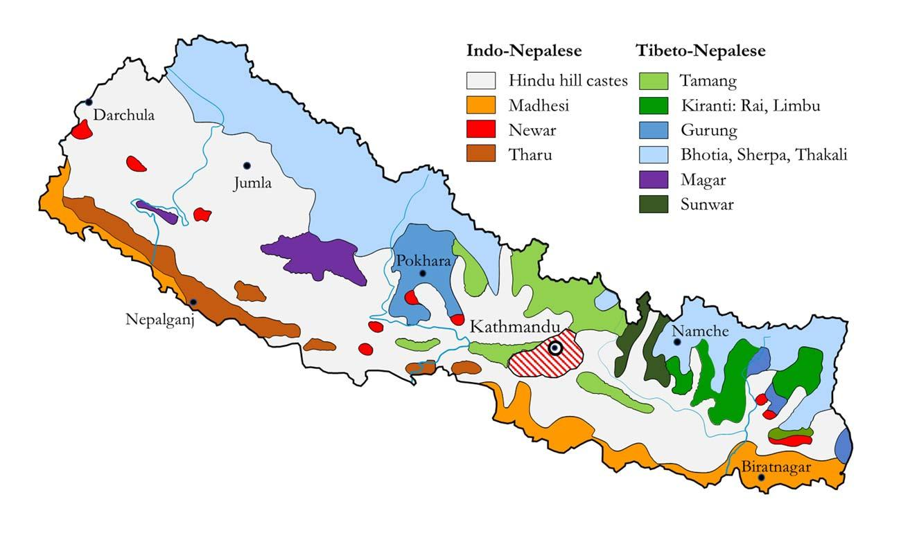

*Figure 4: Nepal’s Ethnic Groups Diversity*

**(Source:** [**https://talesfromthehimalaya.com/maps/**](https://talesfromthehimalaya.com/maps/)**)**

## From Pixels to Traditions: Nepal's Cultural Renaissance in The Digital Age

## Cultural Fusion in Virtual Realms: Gaming as A Catalyst for Global Understanding

"From Pixels to Traditions: Nepal's Cultural Renaissance in the Digital Age" encapsulates the fusion of ancient traditions with modern technology, representing Nepal's innovative approach to preserving and promoting its rich cultural heritage. In this digital era, Nepal is harnessing the power of pixels to breathe new life into age-old traditions, ensuring their survival and relevance in the contemporary world

This topic speaks to Nepal's commitment to leveraging digital tools and platforms to revitalize its diverse cultural landscape. From digital archives and virtual museums to language revitalization apps and interactive storytelling platforms, Nepal is embracing a wide range of initiatives to safeguard its cultural identity. Blending Nepali cultural essence into digital gaming via ICT provides an energetic avenue for safeguarding heritage and promoting learning. These games integrate traditional tales, folklore, music, and customs into gameplay, offering players engaging experiences that educate and entertain simultaneously. Language choices and educational features deepen players' immersion in Nepali culture. By involving communities, employing strategic marketing, and upholding ethical standards, these games become potent vehicles for showcasing Nepali culture globally, nurturing understanding, and creating economic opportunities for local talent.

By joining forces among game developers, cultural authorities, and communities, these games rejuvenate ancient narratives, folklore, melodies, and customs. Through immersive player engagement exceeding mere entertainment, these digital innovations ignite a cultural revival, reigniting curiosity and admiration for Nepal's extensive and varied heritage. These subject beckons readers to delve into the evolution of Nepal's cultural terrain in the digital age, propelled by the merging of technological advancements with traditional elements.

*Figure SEQ Figure \* ARABIC 5: Fusion of indigenous cultures within a vibrant, futuristic gaming environment, emphasizing global understanding and cultural preservation through technology*

Entertainment via gaming and the preservation of cultures are closely intertwined, mutually reinforcing each other's significance and influence. Gaming serves as an immersive platform, allowing players to delve into cultural narratives, traditions, and visual styles, encouraging engagement and inquisitiveness. By seamlessly integrating precise cultural depictions and historical contexts within gameplay, games become valuable educational tools, fostering greater awareness and admiration for various cultural heritages. Moreover, digital games play a crucial role in safeguarding intangible cultural legacies in digital forms, guaranteeing their accessibility and longevity for future generations. Collaboration with cultural authorities and local communities ensures that gaming projects authentically capture and promote cultural practices, nurturing a sense of cultural pride and belonging. Additionally, the global accessibility of gaming breaks geographical barriers, facilitating the widespread dissemination of cultural preservation efforts and fostering cross-cultural appreciation. In essence, gaming emerges as a dynamic medium that not only entertains but also educates, preserves, and celebrates the diverse cultural tapestry of our world.

## Social Media Synergy: Nurturing Cultural Heritage Through Social Media Networks

## Nepal's Cinematic Odyssey: From Kathmandu's Ancient Alleys to Cannes' Glittering Red Carpet

Social media has become a potent instrument for preserving cultural heritage and to celebrate diverse cultural traditions. Platforms such as Facebook, Twitter, Instagram, and YouTube serve as digital repositories where individuals and communities can archive cultural artifacts and stories, ensuring their longevity for future generations. These platforms also serve as catalysts for cultural awareness, fostering understanding and appreciation among a global audience. Furthermore, social media facilitates online communities where people can gather to discuss, honor, and exchange knowledge about their cultural heritage. Through crowd-sourced documentation and digital storytelling, social media captures a wide array of perspectives, enriching the collective cultural narrative. Additionally, it serves as an educational tool, providing resources and insights to a broad audience. Through global collaboration fostered by social media, individuals and organizations work together to preserve and promote cultural diversity worldwide. In essence, social media's role in cultural preservation spans digital archiving, community engagement, education, and international cooperation.

Social media significantly enhances the preservation of cultural heritage through its dynamic and interactive features, with platforms like Facebook, Twitter, Instagram, and YouTube serving as robust tools for safeguarding and promoting cultural traditions, practices, and artifacts. Initially, social media offers a digital arena where individuals and communities can instantly share their cultural experiences, stories, and memories, ensuring the conservation of intangible cultural heritage that might otherwise fade away. Users have the ability to upload photos, videos, and written accounts of cultural events, rituals, festivals, and daily customs, effectively building a virtual repository of cultural diversity. Social media fosters active community engagement and involvement in cultural preservation endeavors. By facilitating connections and collaborations among people from varied backgrounds, it enables the formation of online communities centered around specific cultural interests. These digital spaces serve as platforms for knowledge-sharing, idea exchange, and the organization of cultural activities, thus contributing significantly to the ongoing preservation and rejuvenation of cultural practices.



*Figure 6: Vibrant use of social media to nurture and promote the cultural heritage of Nepal*

**(Source: AI)**

Additionally, Cultural institutions, museums, and heritage sites leverage social media platforms to showcase their collections, host virtual exhibitions, and interact with audiences worldwide. This heightened visibility effectively raises awareness about cultural heritage and encourages public engagement in its conservation efforts.

Moreover, social media plays a vital role in transmitting cultural knowledge and traditions across generations. With younger demographics immersed in digital technologies, they can readily access and engage with cultural content shared on social media platforms, fostering a sense of connection to their cultural heritage and identity.

# SWOT Analysis for ICT in Preserving and Promoting Indigenous Cultures and Languages in Nepal

ICT has the potential to significantly enhance the preservation and promotion of indigenous cultures and languages in Nepal. The increasing penetration of internet and mobile devices facilitates technological accessibility, offering diverse tools like digital archiving and e-learning platforms that enable global reach and community engagement. These technologies can enhance educational resources and promote cultural pride. However, challenges include limited internet connectivity in remote areas, risks of misrepresentation, and sustainability issues. Opportunities lie in continuous technological advancements, growing global awareness, and potential partnerships with technology firms and NGOs. Yet, rapid technological changes, data privacy concerns, economic instability, and resistance from within communities pose significant threats to the success of ICT initiatives.

## Threats and Limitations

* **Access Issues:** Limited internet connectivity and availability of digital tools in many indigenous communities can hinder the implementation and effectiveness of ICT-based cultural preservation strategies.
* **Cultural Sensitivity:** Ensuring respect and control over cultural assets is essential. It is crucial to handle cultural data and materials with sensitivity to avoid misrepresentation and misuse.
* **Sustainability:** Ongoing maintenance and funding are challenging. Ensuring the long-term sustainability of ICT initiatives for cultural preservation requires continuous financial and technical support.
* **Localization:** Creating appropriate content for diverse languages and cultures is complex. Tailoring digital resources to suit the linguistic and cultural nuances of various indigenous communities demands significant effort and expertise.
* **Community Engagement:** Ensuring active participation from indigenous communities can be difficult. Engaging community members and encouraging their involvement in ICT initiatives is vital for the success of cultural preservation efforts.
* **Data Privacy:** Protecting sensitive cultural data is crucial. Implementing robust data privacy measures is necessary to safeguard the cultural information and materials collected during the research.
* **Rapid Change:** Keeping up with technological advancements is demanding. The fast-paced nature of ICT development requires continuous learning and adaptation to leverage new tools and technologies effectively.
* **Impact Measurement:** Assessing qualitative benefits is hard to quantify. Evaluating the impact of ICT-based cultural preservation initiatives involves measuring intangible outcomes, which can be challenging to quantify and analyze.

## Weakness and Problems

Indigenous cultures and languages worldwide are at risk of disappearing due to globalization, economic pressures, and the dominance of major languages. This has led to a loss of cultural identity, traditional knowledge, and language diversity. Many indigenous languages lack resources for education and documentation, exacerbating their decline.

## Solutions and Opportunities

Utilize Information and Communication Technologies (ICT) to preserve and promote indigenous cultures and languages through the following strategies:

* **Digitally Document Oral Histories and Language Resources:** Use digital tools to record and archive oral histories and language resources, ensuring their preservation for future generations.
* **Develop Interactive E-Learning Platforms for Language Revitalization:** Create engaging and interactive e-learning platforms to teach and revitalize endangered languages.
* **Engage Communities in Content Creation and Training: Involve** indigenous communities in the creation of digital content and provide training to enhance their capacity to use ICT for cultural preservation.
* **Foster Partnerships with Technology Firms for Sustainable ICT Solutions:** Establish collaborations with technology companies to develop sustainable ICT solutions tailored to the needs of indigenous communities.

# METHODOLOGY

This research adopts a mixed-method approach, integrating both qualitative and quantitative methods. This approach is chosen to comprehensively address the research questions and objectives, providing a holistic understanding of the impact of ICT in preserving and promoting indigenous cultures and languages

## **Research Design**

This study is exploratory and aims to understand the impact of ICT in preserving and promoting indigenous cultures and languages. A survey conducted through Google Forms was chosen as the primary data collection method due to its ability to gather a wide range of responses from a diverse sample. The survey was designed to capture both quantitative and qualitative data to provide a comprehensive understanding of the research questions.

## **Participants**

The target population for the survey included individuals who use information and communication technologies and have an interest in indigenous cultures and languages. Participants were selected through convenience sampling, and the survey was distributed widely using Google Forms to reach a diverse demographic. The estimated sample size was 10-35 respondents. The participants' demographic characteristics varied in terms of occupation. Specifically, many respondents were students, while a few were teachers and technologists. This distribution provided a balanced perspective from different user groups of ICTS.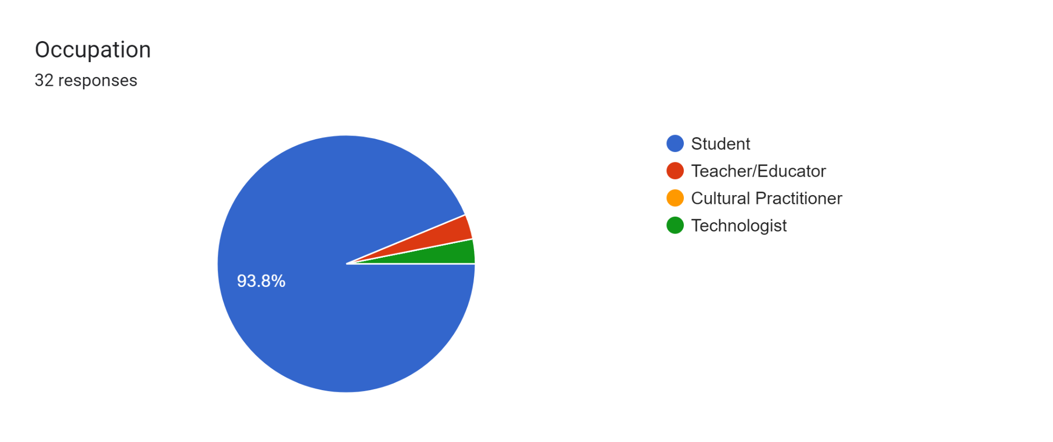

## **Data Collection Methods**

Forms response chart. Question title: How frequently do you use information and communication technologies (ICT) (e.g., internet, smartphones, social media)?  
. Number of responses: 32 responses.The data collection for this study was conducted using Google Forms, a web-based survey tool provided by Google. Google Forms allowed for the creation of a structured survey instrument comprising the following questions:

# Forms response chart. Question title: What types of indigenous content do you access through ICT? . Number of responses: 32 responses.

# 

Forms response chart. Question title: What challenges do you encounter in accessing indigenous cultural and language content through ICT? (Select all that apply)  
. Number of responses: 32 responses.

Forms response chart. Question title: What improvements or additional resources would you recommend for better preserving and promoting indigenous cultures and languages through ICT?  
. Number of responses: 32 responses.Forms response chart. Question title: What do you think are the key challenges that need to be addressed in order to effectively use ICT for the preservation and promotion of indigenous cultures and languages? (Select all that apply)  
. Number of responses: 32 responses.Forms response chart. Question title: Which ICT tools do you utilize most frequently? (Select all that apply)  
. Number of responses: 32 responses.

Forms response chart. Question title: Have you ever shared content related to indigenous cultures and languages on social media?  
. Number of responses: 32 responses.Forms response chart. Question title: What type of content do you find most effective in promoting indigenous cultures and languages? (Select all that apply)  
. Number of responses: 32 responses.Forms response chart. Question title: What policy changes, if any, do you believe are needed to better support the use of ICT for the preservation and promotion of indigenous cultures and languages? (Select all that apply)  
. Number of responses: 32 responses.Forms response chart. Question title: How can indigenous culture and languages be effectively preserved and promoted? (Select all that apply)  
. Number of responses: 32 responses.

Exploring Personal Experiences with ICT in Preserving Indigenous Culture and Language

**Question:** Can you share any personal experiences or examples where ICT has played a role in preserving or promoting your indigenous culture and language?

Several respondents shared diverse examples illustrating how ICT has significantly contributed to the preservation and promotion of indigenous culture and language. For instance, initiatives such as mobile apps have been pivotal in teaching indigenous languages to younger generations, integrating storytelling, traditional music, and folklore. One community highlighted their use of a dedicated YouTube channel where elders share traditional stories, songs, and language lessons, fostering connections to heritage for younger members regardless of geographic distance. Social media platforms were also noted for their role in disseminating cultural knowledge, with examples ranging from e-commerce initiatives selling indigenous products to the global visibility of lesser-known cultures through videos and podcasts. These experiences underscore ICT's transformative impact in bridging cultural gaps and enhancing cultural preservation efforts worldwide.

## **Data Analysis Techniques**

The data collected through Google Forms was analyzed using both quantitative and qualitative methods. Quantitative data underwent statistical analysis to identify patterns and trends, utilizing software tools such as Microsoft Excel and SPSS. Qualitative data were analyzed using thematic analysis, involving coding and manual examination of responses to extract key themes and insights.

## **Ethical Considerations**

Ethical considerations were addressed by obtaining informed consent from all participants. Participants were informed about the purpose of the study, their right to withdraw at any time, and the measures taken to ensure their anonymity and confidentiality. The study adhered to ethical guidelines for research involving human subjects.

# DATA ANALYSIS AND FINDINGS

**Data Analysis Techniques**

The data collected through Google Forms was analyzed using both quantitative and qualitative methods. Quantitative data was analyzed using Microsoft Excel and SPSS to identify patterns and trends. Qualitative data was analyzed using thematic analysis to extract key themes and insights.

**Key Findings**

* **Frequency of ICT Usage:**

Most participants use ICT tools daily.

* **Occupation Distribution:**

Majority of respondents are students, followed by teachers and technologists.

* **Common ICT Tools Used:**

Social media and smartphones are the most commonly used ICT tools.

* **Content Sharing on Social Media:**

Many participants have shared content about indigenous cultures and languages on social media.

* **Effective Content Types:**

Videos and images are the most effective content types for promoting indigenous cultures and languages.

* **Challenges in Accessing Content:**

Participants face challenges like lack of content, internet access issues, and language barriers.

* **Recommendations for Improvement:**

Suggestions include creating more localized content, improving internet infrastructure, and providing language support.

* **Key Challenges:**

Major challenges include the digital divide, content availability, and cultural sensitivity.

* **Personal Experiences:**

Many participants shared positive experiences of using ICT to preserve and promote their indigenous cultures and languages.

* **Policy Changes Needed:**

Participants suggested policies to support digital literacy, content creation, and cultural preservation.

* **Preservation and Promotion Strategies:**

Effective strategies include community-driven content creation, educational programs, and government support.

# DISCUSSION

In our study on "The Impact of ICT in Preserving and Promoting Indigenous Cultures and Languages," we found several key insights. Firstly, ICT, including tools like mobile apps and social media platforms, plays a crucial role in teaching indigenous languages and sharing cultural knowledge. Many respondents highlighted how these technologies facilitate language learning and preserve traditional stories and songs through digital platforms.

However, our findings also revealed challenges. Access to ICT remains a barrier for some communities, limiting their ability to fully engage in cultural preservation efforts. Issues such as internet connectivity and technological literacy were cited as obstacles. Despite these challenges, there are significant opportunities for improvement. Participants suggested initiatives like community-led digital literacy programs and improved internet infrastructure to enhance ICT accessibility.

Moreover, participants expressed a strong desire for more culturally sensitive ICT tools. They emphasized the importance of preserving indigenous knowledge and promoting cultural diversity through digital platforms. By incorporating indigenous perspectives into ICT development, stakeholders can better support cultural preservation efforts and empower indigenous communities to share their heritage globally.

CONCLUSION

The report examines how ICT plays a crucial role in protecting and promoting indigenous cultures and languages. It highlights how technology, such as digital archives, language apps, and online communities, has effectively preserved traditional knowledge, connected dispersed communities, and amplified indigenous voices worldwide. However, challenges like digital inequities and sustainability concerns persist, necessitating ongoing innovation and collaboration. Moving forward, there is a pressing need for inclusive digital strategies that respect and strengthen indigenous cultures, ensuring their enduring presence in the digital era.

# CONTRIBUTIONS AND FUTURE WORKS

CONTRIBUTIONS

Our study on "The Impact of ICT in Preserving and Promoting Indigenous Cultures and Languages" contributes to understanding how digital technologies can support cultural preservation efforts among indigenous communities. By surveying participants on their ICT usage and perceptions, we highlighted the significant role of mobile apps, social media, and other digital tools in teaching languages, sharing traditional knowledge, and promoting cultural diversity globally. Our findings emphasize the importance of culturally sensitive ICT initiatives that empower indigenous communities to preserve and celebrate their heritage in the digital age.

FUTURE WORKS

Moving forward, efforts should focus on enhancing ICT accessibility in underserved indigenous communities. This includes developing culturally relevant digital platforms that respect and promote indigenous languages and traditions. Advocating for policies that protect indigenous cultural rights online is crucial for ensuring fair representation and safeguarding cultural heritage. Longitudinal studies are also needed to evaluate the lasting impact of ICT initiatives on sustaining and celebrating indigenous cultures. These steps will help harness ICT effectively in preserving and promoting indigenous heritage globally.

# Budget Details

|  |  |  |
| --- | --- | --- |
| **Item** | **Description** | **Cost (NPR)** |
| **Personnel** | | |
| Research Coordinator | Overall project management (5 months) | **60,000** |
| Field Researchers (2) | Conducting surveys and interviews (1 month each) | **50,000** |
| IT Expert | Guidance on ICT tools and data management (2 months) | **30,000** |
| Cultural Anthropologist | Expert on indigenous cultures and languages (2 months) | **40,000** |
| Data Analyst | Data analysis and report preparation (2 months) | **30,000** |
| **Travel and Transportation** | | |
| Local Travel | Transportation for field researchers | **10,000** |
| **Survey Materials** | | |
| Printing and Stationery | Questionnaires, consent forms, and other materials | **7,000** |
| **Devices** | | |
| Digital Data Collection Devices | Renting or borrowing (if required) | **15,000** |
| **Miscellaneous** | | |
| Contingency Fund | Unexpected expenses | **25,000** |
| **Total** | | **267,000** |

*Table 1: Budget Details*

# List of Experts

1. **Research Coordinator:** Responsible for overall project management, coordination, and reporting.
2. **Field Researchers (2):** Conduct surveys and interviews within local communities near Kathmandu Valley.
3. **IT Expert:** Provides guidance on the use of ICT tools and data management techniques.
4. **Cultural Anthropologist:** Expert in indigenous cultures and languages, providing insights and validation of cultural data.
5. **Data Analyst:** Analyzes collected data and assists in report preparation.

# Project Phases

**Phase 1: Research Design and Preparation**

* Planning and strategy development
* Team coordination and task assignment

**Phase 2: Questionnaire Development:**

* Designing survey and interview questions
* Pilot testing and refinement

**Phase 3:** **Data Collection:**

* Conducting field research
* Surveys and interviews with stakeholders

**Phase 4: Data Analysis:**

* Qualitative analysis of interview and survey data
* Quantitative analysis using statistical software

**Phase** **5**: **Reporting and Dissemination:**

* Compiling findings and drafting the report
* Reviewing and finalizing the report

# Project Schedule

|  |  |
| --- | --- |
| **Activity** | **Duration (months)** |
| 1. Research Design and Preparation | **0.5** |
| 1. Questionnaire Development | **0.5** |
| 1. Data Collection | **2** |
| 1. Data Analysis | **1** |
| 1. Reporting and Dissemination | **2** |
| Total Duration | **6** |

*Table 2: Project Schedule*

|  |  |  |  |  |  |  |  |  |  |  |  |  |  |  |  |  |  |  |  |  |  |  |  |  |  |
| --- | --- | --- | --- | --- | --- | --- | --- | --- | --- | --- | --- | --- | --- | --- | --- | --- | --- | --- | --- | --- | --- | --- | --- | --- | --- |
| **S.N.** | **Activities** | **Month 1** | | | | **Month 2** | | | | **Month 3** | | | | **Month 4** | | | | **Month 5** | | | | **Month 6** | | | |
| **1** | **2** | **3** | **4** | **5** | **6** | **7** | **8** | **9** | **10** | **11** | **12** | **13** | **14** | **15** | **16** | **17** | **18** | **19** | **20** | **17** | **18** | **19** | **20** |
| **Phase - 1** | **Research Design and Preparation** | | | | | | | | | | | | | | | | | | | | | | | | |
| 1 | Planning and strategy development |  |  |  |  |  |  |  |  |  |  |  |  |  |  |  |  |  |  |  |  |  |  |  |  |
| 2 | Team coordination and task assignment |  |  |  |  |  |  |  |  |  |  |  |  |  |  |  |  |  |  |  |  |  |  |  |  |
| **Phase - 2** | **Questionnaire Development** | | | | | | | | | | | | | | | | | | | | | | | | |
| 1 | Designing survey and interview questions |  |  |  |  |  |  |  |  |  |  |  |  |  |  |  |  |  |  |  |  |  |  |  |  |
| 2 | Pilot testing and refinement |  |  |  |  |  |  |  |  |  |  |  |  |  |  |  |  |  |  |  |  |  |  |  |  |
| **Phase - 3** | **Data Collection** | | | | | | | | | | | | | | | | | | | | | | | | |
| 1 | Conducting field research |  |  |  |  |  |  |  |  |  |  |  |  |  |  |  |  |  |  |  |  |  |  |  |  |
| 2 | Surveys and interviews with stakeholders |  |  |  |  |  |  |  |  |  |  |  |  |  |  |  |  |  |  |  |  |  |  |  |  |
| **Phase - 4** | **Data Analysis** | | | | | | | | | | | | | | | | | | | | | | | | |
| 1 | Qualitative analysis of interview and survey data |  |  |  |  |  |  |  |  |  |  |  |  |  |  |  |  |  |  |  |  |  |  |  |  |
| 2 | Quantitative analysis using statistical software |  |  |  |  |  |  |  |  |  |  |  |  |  |  |  |  |  |  |  |  |  |  |  |  |
| **Phase - 5** | **Reporting and Dissemination** | | | | | | | | | | | | | | | | | | | | | | | | |
| 1 | Compiling findings and drafting the report |  |  |  |  |  |  |  |  |  |  |  |  |  |  |  |  |  |  |  |  |  |  |  |  |
| 2 | Reviewing and finalizing the report |  |  |  |  |  |  |  |  |  |  |  |  |  |  |  |  |  |  |  |  |  |  |  |  |

# **Work Scheduling and Planning**

*Table 3: Work Scheduling and Plan*

# REFERENCES

* *Eagle, S. (Online, 2010). The language situation in Nepal. Journal of Multilingual and Multicultural Development, 20(4-5), 272-327.* [*https://dx.doi.org/10.1080/01434639908666382*](https://dx.doi.org/10.1080/01434639908666382)
* *Wotherspoon, T. (2015). Formal and informal indigenous education. In W.J. Jacob, S.Y. Cheng, & M.K. Porter (Eds.), Indigenous education: Language, culture and identity (pp. 77-98). Springer.* [*https://doi.org/10.1007/978-94-017-9355-1_4*](https://doi.org/10.1007/978-94-017-9355-1_4)
* *Google Scholars 2024 “The Impact of ICT in Preserving and Promoting Indigenous Cultures and Languages.”* [*https://scholar.google.com/*](https://scholar.google.com/)